NEW A145-Dis-Eur-France-Venus de Tursac

**Formal Label: France, Venus de Tursac**

**Display Description: This enigmatic sculpture in a red-brown calcite is a headless abstract female anthropomorph that has a protruding belly and protruding buttocks**

**Accession Number: A145**

**LC Classification:** GN772.22.F7

**Date or Time Horizon:** 25,000 BP

**Geographical Area:** Tursac, a village in the Perigord, near Sarlat

**Map, GPS Coordinates**: 44.96915 1.04491; 40° 26' 46" N 79° 58' 56" W.



Map of Tursac after Delporte (1968).

**Cultural Affiliation:** Upper Paleolithic

**Medium:** calcite

**Dimensions: original, H 8 cm  
Weight: original, 57.4 gm**

**Provenance:**: original, Musée d'Archeologie Nationale et Domaine, St-Germain-en-Laye

**Condition:** Reproduction in resin

**Discussion:** fromDelporte (1968):On Wednesday, August 5, 1959, at 9 am, Mr. Robert Antoine-Charles, working under the direction of Mr. Henri Delporte, a professor at Montbrison (Loire), had begun the digging up slabs from the sterile layer above the red coloured archaeological layer which is the subject of studies undertaken this year, following the sondage 72 in 1958.

Below slabs cemented by deposits of calcite and linked with yellowish clay, M. Antoine found something interesting, and after washing it turned out to be a female statuette. It was in the archaeological layer containing small slabs bearing traces of red. The object was located in square 81.   
The location with respect to the control point, a zero engraved in the wall of the shelter are: depth 25 mm, longitudinal distance 3180 mm, transverse distance 670 mm SE. Distance perpendicular to the wall, 180 mm.   
It is a statuette of a conventional type in yellowish light brown, translucent, with dimensions:   
Height: 80.4 mm, maximum width: 22.5 mm, maximum thickness: 37.4 mm (anteroposterior) and weighs 57.5 g.   
The head is of subconical shape, with a flexed position, protruding belly and buttocks, arms not shown, thighs and legs clearly shown, heels slightly apart, and at the base, an appendix on the nature of which we are reduced to speculation [but could be an anchoring protrusion, enabling it to be put in sand or earth].

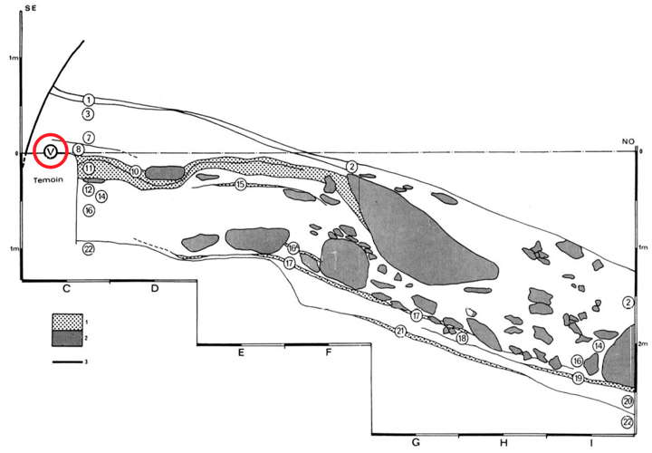

Plan section of cave where the figurine was found, after Delporte (1968).

Key: 2 (grey pattern) - blocks fallen from the roof of the abri  
3 (solid line) - back wall of the abri  
V (circled in red) - position of the female statuette

Text and photos below from White (2002):  
In 1959, at l'abri du Facteur, Tursac, Dordogne, H. Delporte (Delporte 1959, 1960, 1968)found a pebble of amber coloured calcite transformed into a female representation. This statuette (MAN 81693) is precisely dated to the Gravettian:  
Oxa 583 …………24 720 ± 600  
Oxa 584………….24 210 ± 500  
Oxa 585………….24 400 ± 600  
Oxa 586………….24 690 ± 600  
Oxa 594………….24 450 ± 650  
Oxa 595………….24 630 ± 650  
  
It is 8.1 cm high, roughly the same size as that of Milandes. It has the same smooth contours, partly natural, and the same arched back. In addition, some researchers (Delporte 1960, 1968) saw a phallus in the part of the statue which goes down between the folded legs. We undertook microscopic analysis of the Tursac Venus. Apart from a few very fine and superficial scratches on some of the surfaces and streaks of scratching from the erasure of marking ink, this statue shows an almost complete absence of evidence of shaping.  
Yet she was found in a rock solid context, and the form also leaves no doubt that this is a prehistoric sculpture. It was formed almost solely by abrasion and polishing. and not, as we assumed, by the techniques of scraping and cutting with flint tools. We were especially struck by what could be taken (to the naked eye) for incisions which put in relief, for example, the thighs against the abdomen. But in fact these are not incisions in the usual sense, made with a sharp flint. Rather, the grooves were created by an abrasive tool to round the contours. The method used was more like that of a file. The base of these grooves bear no streaks of abrasion, but sometimes we see the intersection of two distinct furrows (Fig. 27) as if there was a change in the angle of application.   
  
Reassuringly, we see precisely the same thing on the statue of Milandes (Fig. 16) In short, if this object was found in a field outside an archaeological context, it could not seek to verify its authenticity by the marks of flint tools. It would have to be identified, or not, by its form.

Fig. 26 - The surface of the Venus of Tursac. Traces of polishing are nearly absent and when they exist, they are extremely fine and superficial (6.4x).  
  
Photo: R. White  
Source: White (2002)

[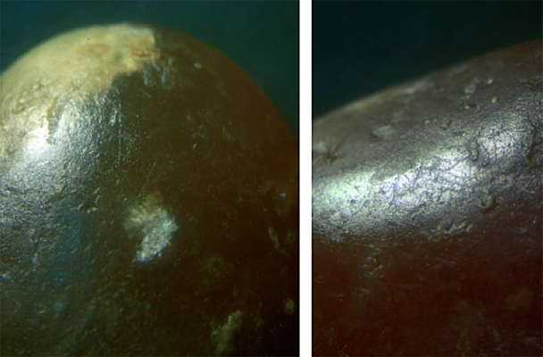](http://donsmaps.com/images24/scratchestursac.jpg)  
  
  
Fig. 27 - The Vénus of Tursac.  
  
At left, the limit between the abdomen and the left thigh. Two converging grooves are visible.   
  
At right, details of the grooves showing the rounded and featureless bottoms.   
  
Compare with fig. 16 (6.4x and 18x).  
  
Photo: R. White  
Source: White (2002)   
[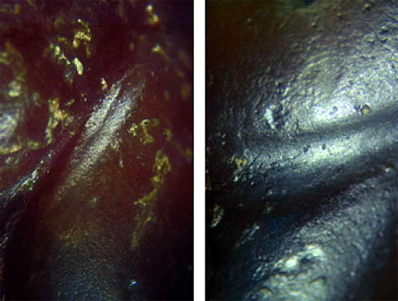](http://donsmaps.com/images24/tursacgrooves.jpg)

**References:**

**Delporte, H.** 1959. “Une nouvelle statuette paléolithique: la Vénus de Tursac,” *L’Anthropologie*, 63: 232-245.

**Delporte, H.** 1960. “Problèmes d’interprétation de la Vénus de Tursac,” *Quartär*, 12: 119-129.

**Delporte, H.** 1968. “Étude générale, industrie et statuette,” *Gallia préhistoire*, 11(1): 1-112.

**White, R.** 2002. “Une nouvelle statuette phallo-féminine paléolithique: 'La venus des Milandes' (commune de Castelnaud-la-Chapelle, Dordogne,” *Paleo* N° 14 Décembre, pp.177-198.